**1.Write the steps “ using git how to push code in github/gitlab/bitbucket”.**

**=** The following steps are:-

.git init (to create the .git folder and also to make the code folder into a special folder or to create the three areas ex- working area, staging area and local repo)

.git add (to move the files from working area to staging area)

.git commit -m “ Your message ” (to move your code from staging area to local repo)

.git remote add origin <HTTP link> (to connect your local repo with remote repo)

.git push -f origin <branch name> (to push your code into remote repo)

**2.Write a C program to sort the elements of Array.**

= The below code is a bubble sort algorithm:-

#include <stdio.h>

int main() {

int n, i, j, temp;

int arr[100];

printf("Enter the size of the array: ");

scanf("%d", &n);

printf("Enter %d integers: \n", n);

for (i = 0; i < n; i++) {

scanf("%d", &arr[i]);

}

// Bubble Sort Algorithm

for (i = 0; i < n-1; i++) {

for (j = 0; j < n-i-1; j++) {

if (arr[j] > arr[j+1]) {

// swap the elements

temp = arr[j];

arr[j] = arr[j+1];

arr[j+1] = temp;

}

}

}

printf("The sorted array is: \n");

for (i = 0; i < n; i++) {

printf("%d ", arr[i]);

}

printf("\n");

return 0;

}

**3.Explain Waterfall model,Agile and Devops in breaf.**

= The Waterfall model, Agile, and DevOps are three different software development lifecycle methodologies.

The Waterfall model is a linear and sequential approach to software development. It is a structured methodology that follows a series of sequential stages, starting with requirements gathering, followed by design, implementation, testing, and deployment. Each stage is completed before moving on to the next one, and changes made at later stages can be difficult and costly to implement.

Agile is an iterative and incremental approach to software development that emphasizes flexibility and adaptability. It involves breaking the development process into small, manageable chunks called sprints. During each sprint, a small set of features is developed, tested, and reviewed before being integrated into the final product. Agile methodology emphasizes communication and collaboration among team members, customers, and stakeholders to ensure that the final product meets the user's needs.

DevOps is a methodology that emphasizes collaboration and communication between development and operations teams to streamline the software development process. DevOps involves continuous integration, continuous delivery, and continuous deployment to ensure that the software is always ready for deployment. DevOps is characterized by a high degree of automation and emphasizes frequent and fast delivery of code changes to meet the needs of the business.

**4.What is operating system? write at least 20 commands of linux os.**

= An operating system (OS) is a software program that manages computer hardware and software resources and provides common services for computer programs. It acts as an intermediary between applications and the computer hardware, allowing applications to communicate with the hardware without needing to know the details of how the hardware works. The OS provides key functions such as managing memory and processing resources, input/output operations, file systems, storage devices, and user interfaces. Examples of popular OSs include Microsoft Windows, macOS, Linux, and Android.

**20 commands in linux os:-**

.mkdir <file name>

.cd <file name>

.cd ..

.cat > a

.cat >> a

.cat a

.tac a

.cat a b c … > d

.touch a

.touch -a a

.touch -m a

.stat a

.vi/vim a

.nano a

.mv a b

.cp a b

.cp -r a/p b

.rmdir a

.rm a

.ls

**5.What is shell script? Write program for**

**1.Hello World 2.Variable 3.Operators 4.Control Statement 5.Function**

= A shell script is a program written in a scripting language that is interpreted by the shell of an operating system, typically a Unix-based system. It is used to automate and simplify repetitive tasks, execute system commands, and manipulate files and directories. Shell scripts are commonly used for system administration, data processing, and software development tasks.

**1.Hello world program**

#!/bin/bash

echo "Hello, World!"

**2.Variable program**

#!/bin/bash

echo "Enter the number:"

read num

echo "The number is $num"

**3.Operators program**

#!/bin/bash

# Arithmetic operator

num1=10

num2=5

echo "Arithmetic operators:"

echo "num1 + num2 = $(($num1 + $num2))"

echo "num1 - num2 = $(($num1 - $num2))"

echo "num1 * num2 = $(($num1 * $num2))"

echo "num1 / num2 = $(($num1 / $num2))"

echo "num1 % num2 = $(($num1 % $num2))"

echo

# Comparison operators

str1="hello"

str2="world"

echo "Comparison operators:"

echo "num1 -eq num2 = $((num1 == num2))"

echo "num1 -ne num2 = $((num1 != num2))"

echo "num1 -gt num2 = $((num1 > num2))"

echo "num1 -lt num2 = $((num1 < num2))"

echo "num1 -ge num2 = $((num1 >= num2))"

echo "num1 -le num2 = $((num1 <= num2))"

echo "str1 == str2 = $((str1 == str2))"

echo "str1 != str2 = $((str1 != str2))"

**4.Control statement program**

#! /bin/bash

#If else condition

echo Enter the 1st number

read a

if [ `expr $a % 2` -eq 0 ]

then

echo The number is even

else

echo The number is odd

fi

echo

#while loop

i=1

while [ $i -le 10 ]

do

echo Number `expr $i \* 2`

i=`expr $i + 1`

done

echo

#forloop

x="1 2 3 4 5 6"

for i in $x

do

echo $i

done

echo

**5.Function program**

#! /bin/bash

#function

function show(){

echo Hi $1 $2

}

show Swagatam Bardhan

**6.Write steps with screen shot for creating project, epic, story, sprint.**

= The following are some few steps:-

1.Log in to Jira software

2.Click on create project

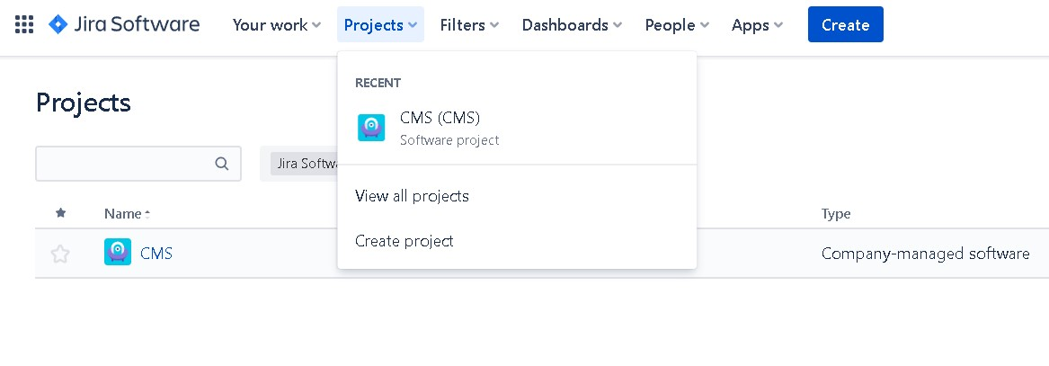

3.Select template. We have to select scrum.

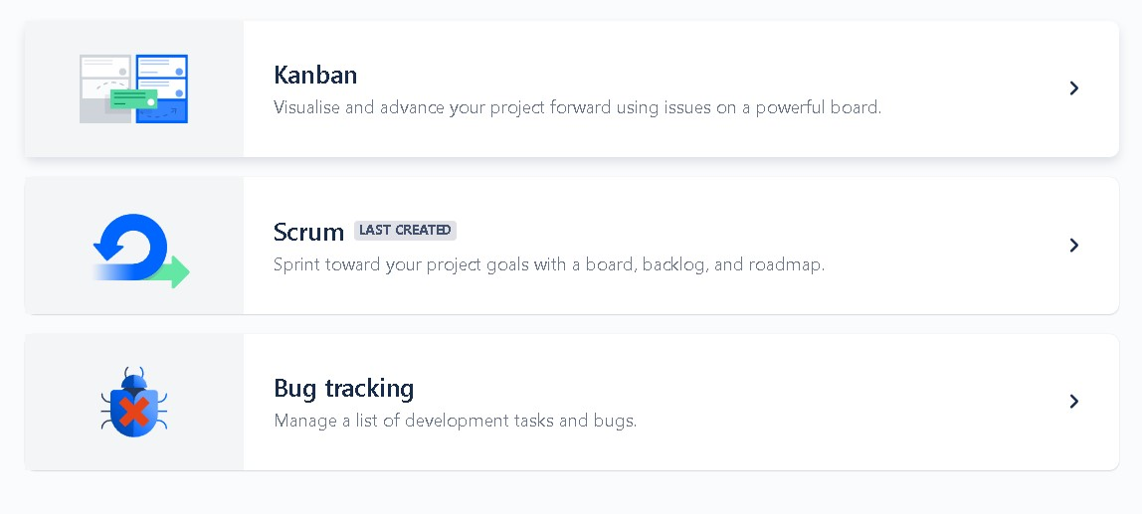

4.After selecting scrum click use template.

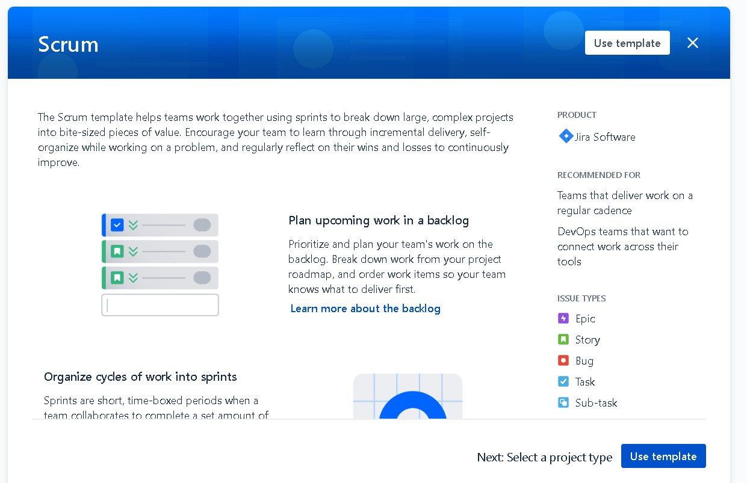

5.Select your project type. Click on “Select a company-managed project”.

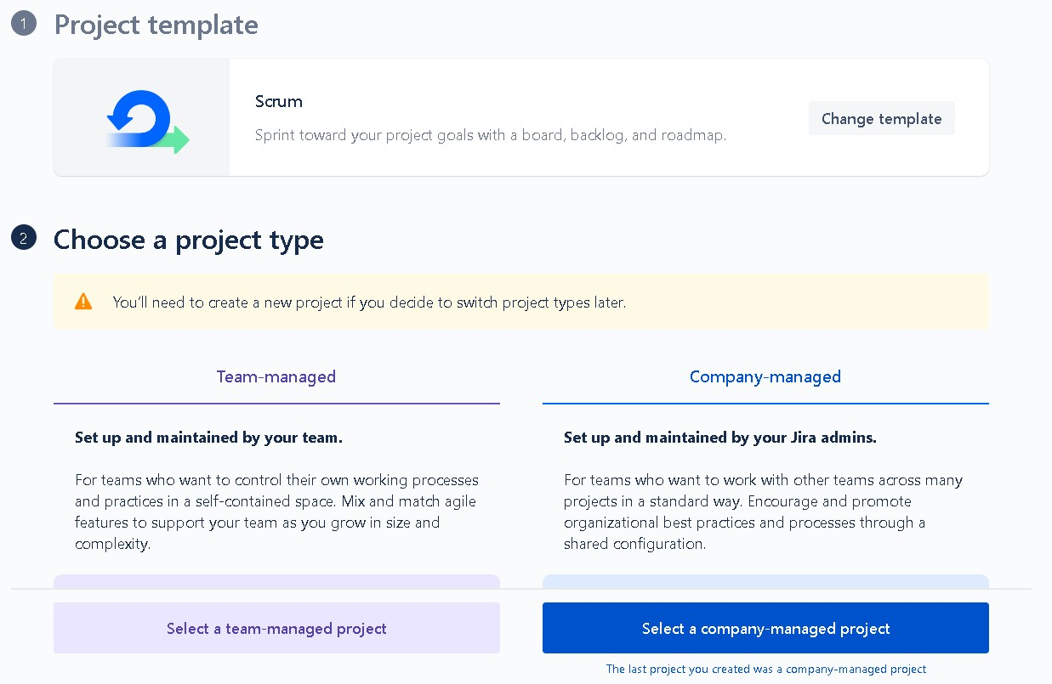

6.Enter your project name and click Crate project. Your project will be created.

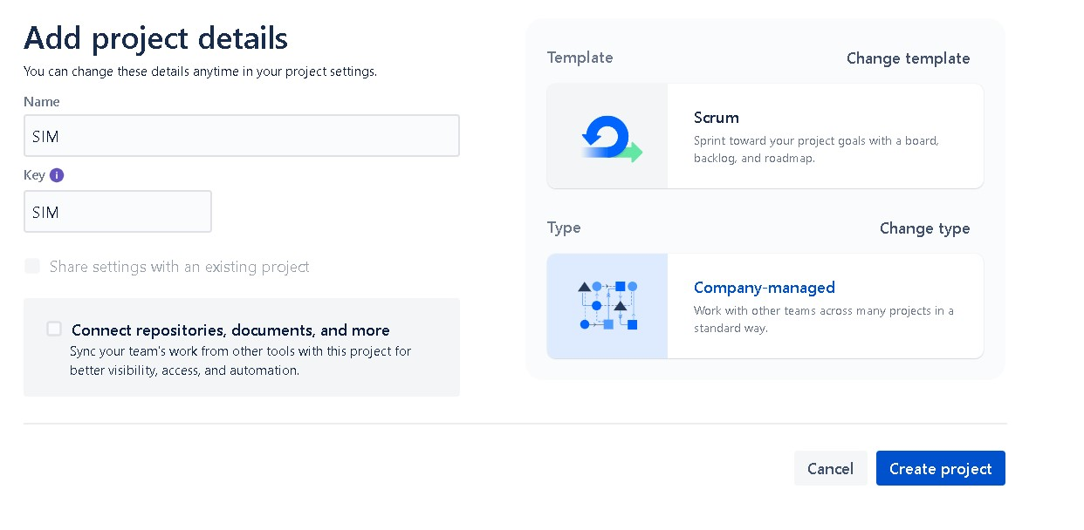

7.Then click on issues on the left side bar, then click on create and select Issue type as Epic.

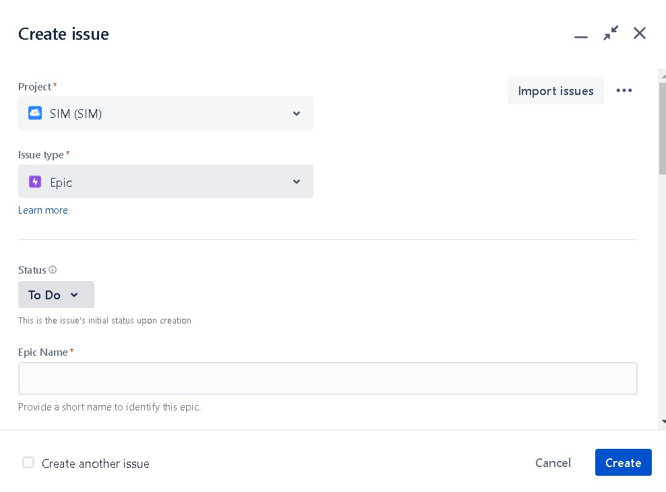

8.Then again click on create and select Issue type as Story, then click create.

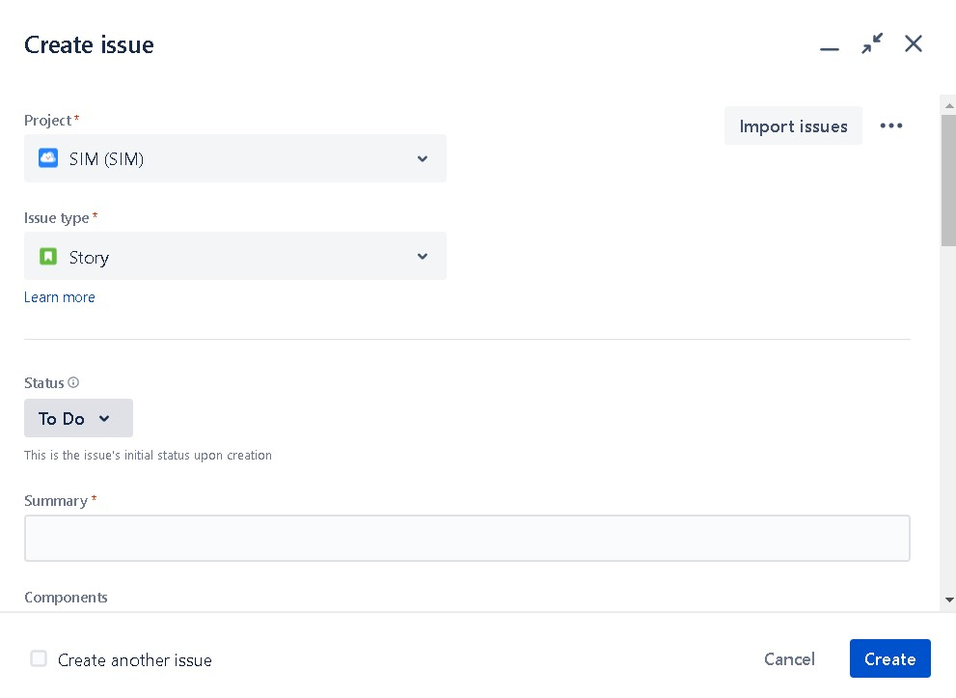

8.Then click on backlogs on the leeft side bar. Here you can see your all backlogs. Now click on Create sprint.

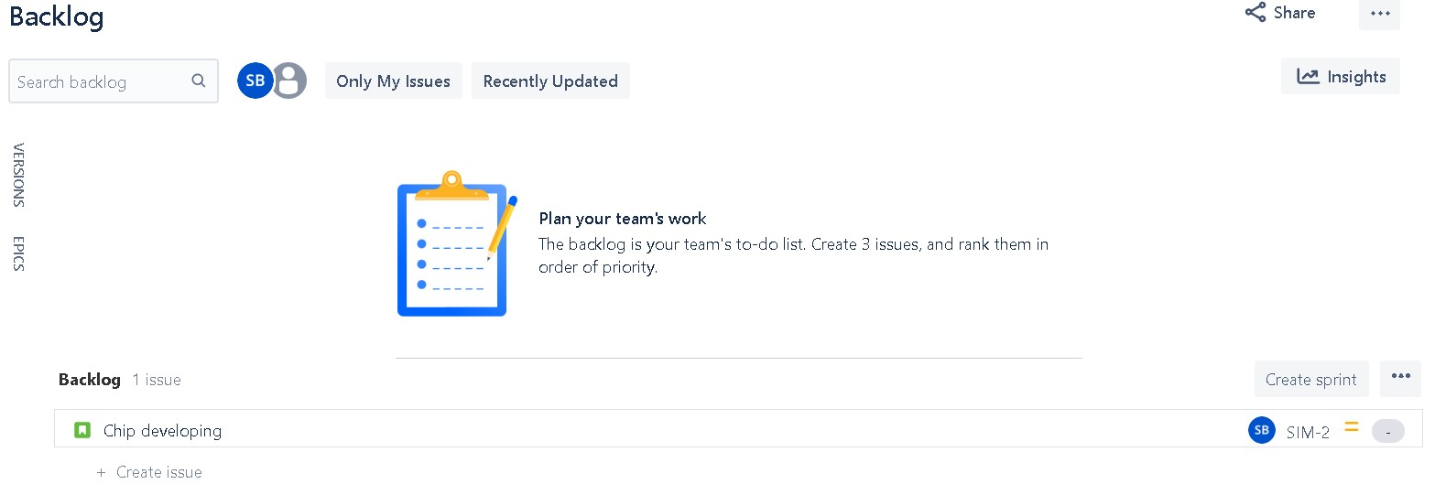

9.After clicking on Create sprint we have to drag the backlogs to sprint option. After that we have to click Start sprint.

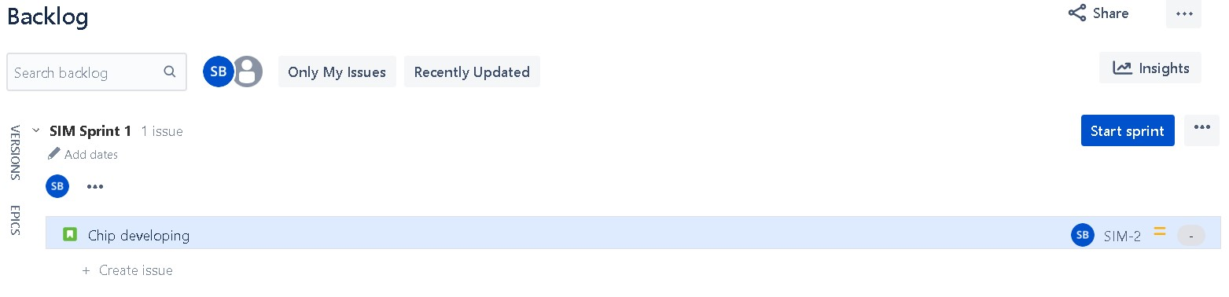

10.Then we have to add duration of our sprint, after adding the time duration click start.

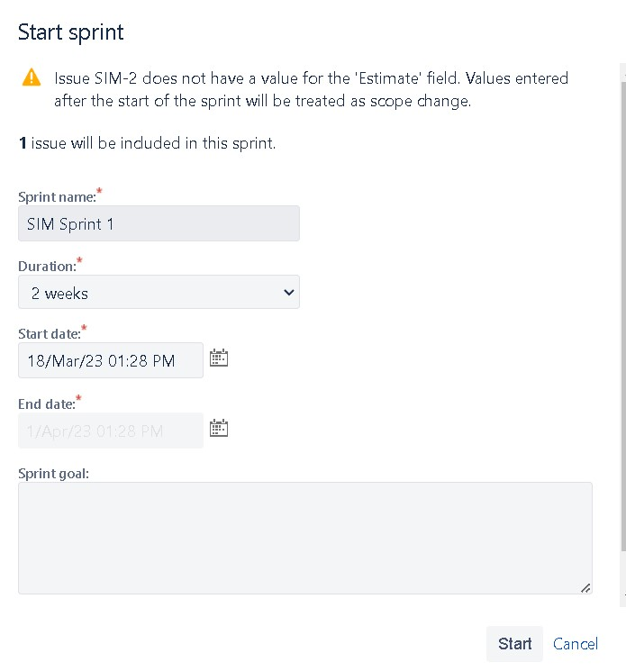

**7.Write various stages of Agile methodology.**

= The following stages are:-

Stage-1:-Create Epic and stories.

Stage-2:-Create Scrum team.

Stage-3:-Create Sprint plan.

Stage-4:-Scrum call (Daily).

Stage-5:-Repeat stage-3 and stage-4.

**8.Diffrence between**

**A.Waterfall model, Agile model and Devops model.**

=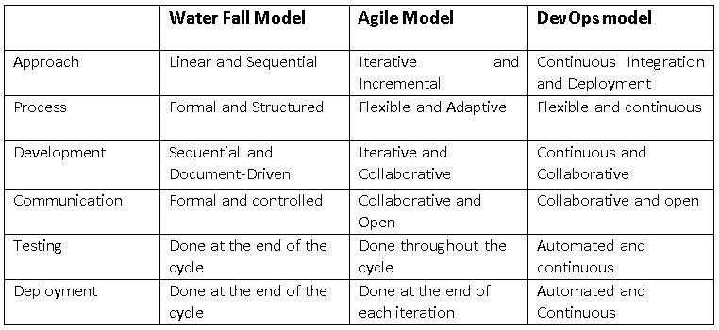

**B.Scrum and Kanban.**

=

| **Aspect** | **Scrum** | **Kanban** |
| --- | --- | --- |
| Philosophy | Iterative, increamental development | Continuous flow of work |
| Roles | Product owner, scrum master, development team | No prescribed roles |
| Backlog Management | Product Backlog, Sprint Backlog | Work items, Backlog |
| Meetings | Daily Scrum, Sprint Planning, Sprint Review, Retrospective | None prescribed, but can have daily stand-up meetings |

**C.Git and Bit-Bucket.**

=

| **Aspect** | **Git** | **Bitbucket** |
| --- | --- | --- |
| Version Control | Distributed version control system | Git-based version control system |
| Hosting | Self-hosted or cloud-based | Cloud-based |
| Repository | Can crate and manage multiple repositories | Can create and manage multiple repositories |
| Access Control | Supports various access control mechanisms | Allows granular permission management |

**D.LVCS and CVCS and DVCS.**

=

| **Aspect** | **LVCS** | **CVCS** | **DVCS** |
| --- | --- | --- | --- |
| Centralization | Centralized, with a single server storing versions | Centralized, with a single server storing versions | Decentralized, with every user having a complete repository |
| Collaboration | Requires exclusive locks to prevent conflicts | Allows concurrent access, but conflicts must be resolved | Allows concurrent access, with automatic merging |
| History | Only stores the latest version | Stores the full history, but only on the central server | Stores the full history locally, with the option to push changes to a central server |
| Offline access | Require network access to access files | Require network access to access files, but may allow caching | Allows full access to the repository, even when offline |
| Branching and Merging | Limited branching and merging capabilities | More advanced branching and merging capabilities | Advanced branching and merging capabilities |

**E.DOS and WINDOWS.**

=

| **Aspect** | **DOS** | **Windows** |
| --- | --- | --- |
| User Interface | Command-line interface | Graphical user interface(GUI) |
| Multitasking | Not a true multitasking system | True multitasking system |
| File system | Support FAT and FAT32 file systems | Supports NTFS file system and FAT/FAT32 for compatibility |
| Ddevice Drivers | Requires specific drivers for hardware | Includes pre-installed drivers for most hardware |
| Memory Management | Uses conventional memory and upper memory | Uses virtual memory for memory management |
| Compatibility | Runs on older hardware | Runs on newer hardware but may not support older software |
| Security | No built-in security features | Includes built-in security features such as user accounts and permissions |

**9.Write name of 15 DevOps tools.**

= **Here are some 15 devops tools:-**

.Jenkins

.Gitlab

.GitHub

.Bitbucket

.Docker

.Kubernetes

.Chef

.Puppet

.Jira

.Selenium

.AWS CloudFormation

.Ansible

.Nagios

.Prometheus

.Grafana

**10.Write names of 10 Cloude providers.**

= **Here are 10 cloud providers:-**

.Amazon Web Services(AWS)

.Microsoft Azure

.Google Cloud Platform(GCP)

.IBM Cloud

.Oracle Cloud

.Alibaba Cloud

.Salesforce Cloud

.Cloudflare

.DigitalOcean

.Linode